**CAPSTONE PROJECT REPORT**

(Project Term January-May 2022)

**Amazon Automation**

Submitted by

**MohithVenkata Sai Vemula- 11802939**

**Naveen ChanduParitala- 11805079**

**Upendar Reddy Baireddy- 11805157**

**BommaPreetham- 11805205**

**Project Group Number**

CSERGC0148

**Course Code :**CSE445

Under the Guidance of

**Ms. Puneet**

**(Assistant Professor)**

# School of Computer Science and Engineering

Lovely Professional University

Phagwara, Punjab (India)

June, 2022

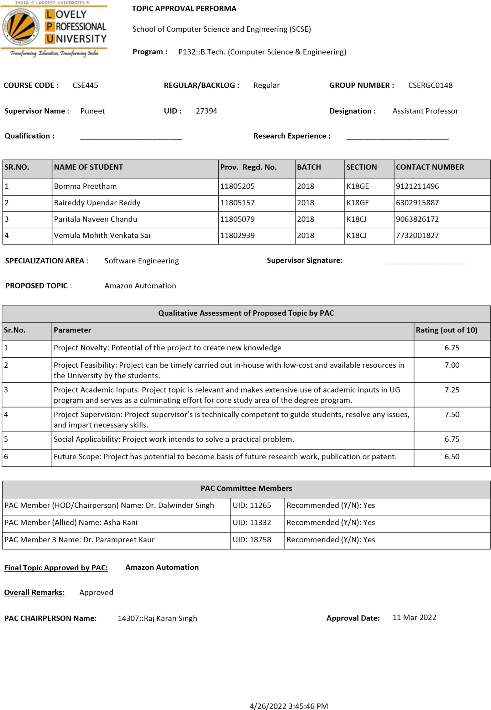

**DECLARATION**

We hereby declare that the project work entitled “Amazon Automation” is an authentic record of our own work carried out as requirements of Capstone Project for the award of B.Tech degree in Computer Science from Lovely Professional University, Phagwara, under the guidance of Ms. Puneet during January-May 2022. All the information furnished in this capstone project report is based on our own intensive work and is genuine.

**Project Group Number:**CSERGC0148

**Name of Student 1:**MohithVenkata Sai Vemula

**Registration Number:** 11802939

**Name of Student 2:**Naveen ChanduParitala

**Registration Number:**11805079

**Name of Student 3:**Upendar Reddy Baireddy

**Registration Number:**11805157

**Name of Student 4:**BommaPreetham

**Registration Number:**11805205

**(**Mohith**)**

**Date:**19/04/2022

**(**Naveen**)**

**Date:**19/04/2022

**(**Upendar**)**

**Date:**19/04/2022

**(**Preetham**)**

**Date:**19/04/2022

**CERTIFICATE**

This is to certify that the declaration statement made by this group of students is correct to the best of my knowledge and belief. They have completed this Capstone Project under my guidance and supervision. The present work is the result of their original investigation, effort and study. No part of the work has ever been submitted for any other degree at any University. The Capstone Project is fit for the submission and partial fulfillment of the conditions for the award of B.Tech degree in Computer Science from Lovely Professional University, Phagwara.

**Signature and Name of the Mentor**

Puneet

**Designation**

Assistant Professor

**School of Computer Science and Engineering,**

Lovely Professional University,

Phagwara, Punjab.

**Date :**19/04/2022

**Acknowledgement**

I would like to express my gratitude and appreciation to all those who gave me the possibility to complete this project. I would like to thank my University Lovely Professional University to give me this opportunity to work on such a great and amazing project. This project helped me a lot to get new knowledge in this field. Special thanks to my Mentor, Ms. Puneet whose help, stimulating suggestions and encouragement helped me in all time of project building process and in writing this report. I also sincerely thanks for the time spent proof reading and correcting my many mistakes.

I would also like to acknowledge with much appreciation my friends and family whose constant support and backing helped me in getting all the research required for this project and helped me in completing the project in time.

**TABLE OF CONTENTS**

Inner first page……………………………………………………………………….(i)

PAC form……………………………………………………………………………(ii)

Declaration…...………………………………………………………………………(ii)

Certificate……..…….………………………………………………………………..(iii)

Acknowledgement…………………………………………………………………...(iv)

Table of Contents……………………...……………………………………………,,(v)

1. **Introduction** 
   1. **What is Selenium?**
   2. **Selenium Components**
   3. **What is Selenium WebDriver?**
   4. **Drawbacks of Selenium WebDriver**
2. **Project Overview**

**2.1 What is Automation?**

**2.2 Project Description**

**2.2.1 Importing the necessary libraries**

**2.2.2 Accessing the WebDriver and opening the website**

**2.2.3 Maximize Window**

**2.2.4 Sign-in or Sign-up page**

**2.2.5 Search item and display the item**

**2.2.6 Add item to Cart**

**2.2.7 Your Account**

1. **Source Code**
2. **Challenges Faced and Areas of**

**4.1 Challenge faced in Sign Up page**

**4.2 Concern in Sign Up page**

**4.3 Empty fields in Cost and Rating**

**1. INTRODUCTION**

* 1. **What is Selenium?**

[Selenium](https://www.browserstack.com/selenium) refers to a suite of tools that are widely used in the testing community when it comes to [cross-browser testing](https://www.browserstack.com/live). Selenium cannot automate desktop applications; it can only be used in browsers. It is considered to be one of the most preferred tool suites for [automation testing](https://www.browserstack.com/guide/automation-testing-tutorial) of web applications as it provides support for popular web browsers which makes it very powerful.

It supports a number of browsers

Google Chrome 12+, Internet Explorer 7,8,9,10, Safari 5.1+, Opera 11.5, Firefox 3+) and operating systems (Windows, Mac, Linux/Unix.

Selenium also provides compatibility with different programming languages –

C#, Java, JavaScript, Ruby, Python, PHP.

Testers can choose which language to design test cases in, thus making Selenium highly favorable for its flexibility.

**1.2 Selenium Components**

The Selenium test suite comprises four main components:-

* Selenium IDE
* **Selenium RC**
* **Selenium WebDriver**
* **Selenium Grid**

**From the Given four components of Selenium we will use the 3rd component i.e. , Selenium WebDriver in our entire project.**

* 1. **What is Selenium WebDriver?**

Selenium WebDriver is a web framework that permits you to execute cross-browser tests. This tool is used for automating web-based application testing to verify that it performs expectedly.

Selenium WebDriver allows you to choose a programming language to create test scripts. It is an advancement over Selenium RC to overcome a few limitations.

**1.4 Drawbacks of Selenium WebDriver**

Selenium WebDriver is not capable of handling window components, but this drawback can be overcome by using tools like Sikuli, Auto IT, etc.

1. **Project Overview**

The title of the project is Amazon Automation – Guide for Amazon. Automation is the term which we regularly keep hearing in our daily lives.

**2.1 What is Automation?**

Automation can be defined as a technique of making a process or a system operate automatically(less human interaction). When we automate a process or a task it reduces the effort and consumes less time.

**2.2 Project Description**

When we open Amazon website or app if you are an old user you sign in using credentials, search item if we want to order any or add item to cart for later purchase. Then if we want to update our account details we go into ‘your account’ and update necessary information and join prime if you are interested. However if you are a new user you create an account first.

The entire project works on amazon website ([www.amazon.in](http://www.amazon.in)) with the help of python language. We use the specific libraries to run commands.

This project helps you just like a guide by bringing all the information and tasks together at one place, all you need to do is select the option from the list and the task is performed for you. Making the technology easily usable and user friendly is the main objective of this project.

* We start by installing the Selenium Library.

pip install -U selenium

* Then we download the Chrome Driver that is compatible with the current version of our chrome browser using the link below.

<https://chromedriver.chromium.org/downloads>

Now we can start our program in any app we are comfortable with. I use the PyCharmapp in my project.

**2.2.1 Importing the necessary libraries**

fromselenium import webdriver

fromselenium.webdriver.support.selectimport Select  
import time

**2.2.2Accessing the WebDriver and opening the website**

We create a variable driver and assign the downloaded chromedriver extension to it. By using “.get” we can open the website.

driver = webdriver.Chrome('chromedriver.exe')  
driver.get('https://www.amazon.in/')

**2.2.3Maximize Window**

After successfully completing step 1 and step 2, when we run it a new automated page is opened to maximize that page we need to use maximize command

driver.maximize_window()

Now finally we get a chrome page with heading chrome is being controlled by automated test software.

Now to automate the website we need to inspect the website that we are using, In our case we need to right click on any spot in amazon website and the click on the inspect option. This gives you the code used for amazon website.

Whenever you inspect particular field in website the code is given to your right side of screen as shown in the picture.

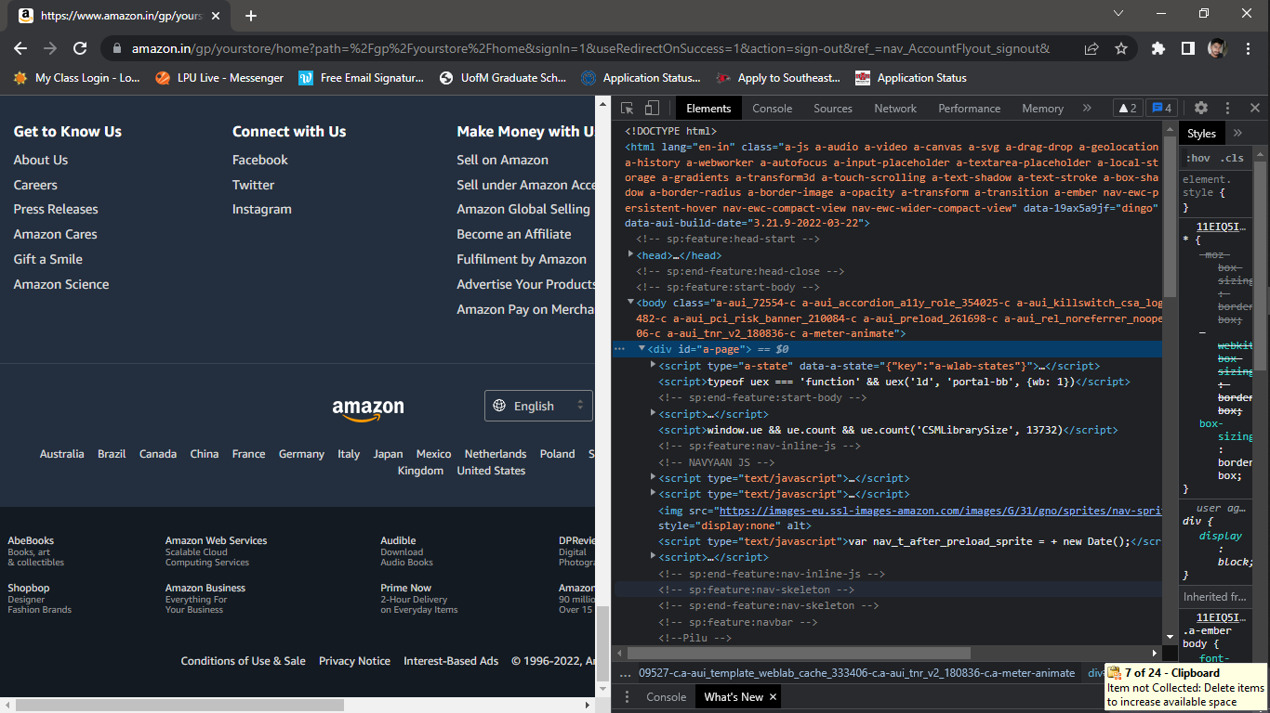

**2.2.4Sign-in or Sign-up page**

When we use any shopping website or any other website, we can access the features to its full extent only when we have an account. So let’s start by automating the sign in/ sign up page.

In order to get the code for some field in website we need to right click on that particular field and click on inspect, then the tag name, class name or id of the field is displayed. We can access this in our code by using the variable we created earlier. The “driver” variable is used with “find_element” in the following way.

driver.find_element_

There are various ways to access the fields in a website, such as

* Id
* Class
* X-path
* Name
* Link_Text

We can use both find_elements and find_element but it’s use depends on various situations. When we use a for loop in the condition we give “find_elements” and inside the loop we give “find_element”

The Picture below shows all the available elements(ways to access):

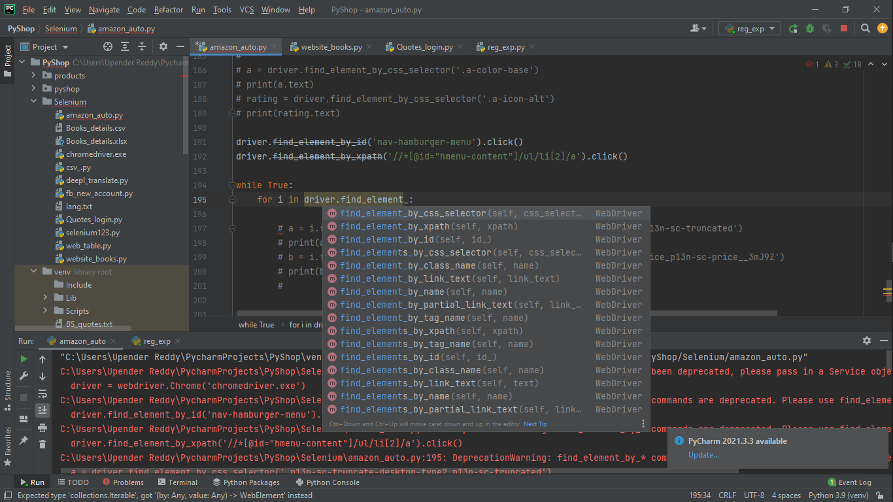

**Sign-In Page of Amazon:**

If you are having an account in amazon you can run the commands for sign in page and in case if you forget the password we can run the commands for forget password.

When we inspect the code for the input column in sign in page the class or id the elements that are available for the field is given. When we hover the mouse onto the highlighted code, the class of the input box is displayed above the box with a “**.**” and id is displayed with “#”.

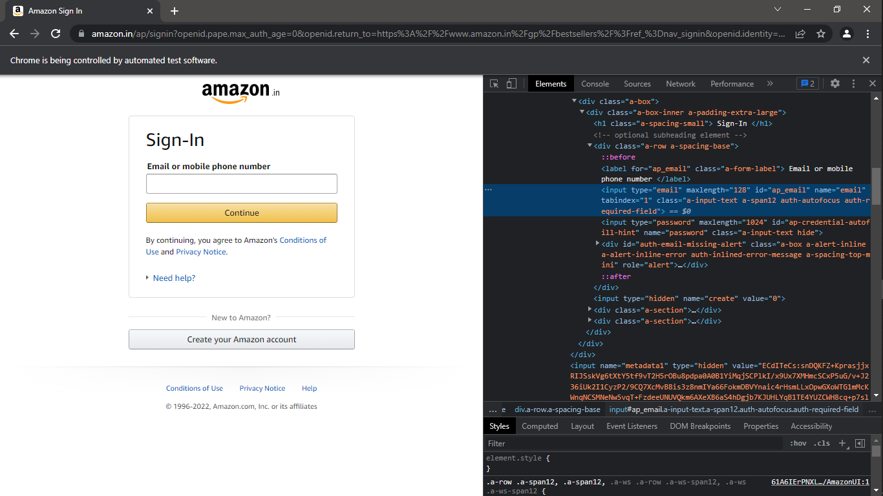

After accessing the input field we enter details in the field using “.send_keys” and then to click on continue button we need to use “.click()” after accessing the button with the class or id.

**Code for Sign-In page:**

login_no = driver.find_element_by_id('ap_email')  
login_no.send_keys(1234567890)  
  
continue_button = driver.find_element_by_id('continue')  
continue_button.click()  
  
login_pass = driver.find_element_by_id('ap_password')  
login_pass.send_keys('Your Password')  
  
sign_In_Submit = driver.find_element_by_id('signInSubmit')  
sign_In_Submit.click()

**Code for Forget Password:**

# Click on forget password  
driver.find_element_by_id('auth-fpp-link-bottom').click()  
driver.find_element_by_id('continue').click()  
  
# Enter otp  
otp = driver.find_element_by_id('cvf-input-code')  
otp.send_keys(int(input("Enter the otp received to phone: ")))  
driver.find_element_by_css_selector('.a-button-input').click()

# Enter new password  
pass_new = driver.find_element_by_id('ap_fpp_password')  
pass_new.send_keys(input("Enter new password: "))  
# Retype the same password  
pass_new_2 = driver.find_element_by_id('ap_fpp_password_check')  
pass_new_2.send_keys(input("Enter new password again: "))  
driver.find_element_by_id('continue').click()

The same way by accessing every required field we can automate the Sign Up page.

**Code for Sign-Up page:**

driver.find_element_by_css_selector('#createAccountSubmit').click()  
time.sleep(1)  
  
name = driver.find_element_by_id('ap_customer_name')

We can either enter details or take input from user using input command

name_ = input("Enter Name that is unique: ")

When you try to automate the sign-up page the issue we face is that there are 2 different types of sign up page and they open at random.

So we need to automate both the pages using “if - else” condition.

**Code for 1st type of sign up page**

for label in driver.find_elements_by_css_selector('.a-form-label'):  
if (label.text) == 'Mobile number or email':  
  
 email = driver.find_element_by_id('ap_email')  
# email_ = input('Enter email: ')  
email.send_keys('*************@gmail.com')  
time.sleep(1)  
 pass_ = driver.find_element_by_id('ap_password')  
# pass__ = input('Enter password 8 characters long with a number and Capital: ')  
pass_.send_keys('********')  
time.sleep(1)  
 pass_1 = driver.find_element_by_id('ap_password_check')  
# pass__1 = input('Re enter the same password: ')  
pass_1.send_keys('********')  
time.sleep(1)

In this case the otp is sent to your mail.

We can enter otp using code

otp1 = (otp_type.find_element_by_id('cvf-input-code'))  
otp2 = int(input("Enter the otp received to your mail:"))  
otp1.send_keys(otp2)  
time.sleep(2)

Then we can submit otp using

otp_type.find_element_by_id('auth-verify-button').click()

**Code for 2ndtype of sign up page**

elif(label.text) == 'Mobile number':  
  
phone_no = driver.find_element_by_id('ap_phone_number')  
# phone_no_ = int(input('Enter mobile number never used before: '))  
phone_no.send_keys(1234567890)  
time.sleep(1)  
  
 email = driver.find_element_by_id('ap_email')  
# email_ = input('Enter email: ')  
email.send_keys('**************@gmail.com')  
time.sleep(1)  
  
 pass_ = driver.find_element_by_id('ap_password')  
# pass__ = input('Enter password 8 characters long with a number and Capital: ')  
pass_.send_keys('********')  
time.sleep(1)

In this case the otp is sent to your mobile.

otp1 = (otp_type.find_element_by_id('auth-pv-enter-code'))  
# otp2 = int(input("Enter the otpreceived to your mobile:"))  
otp1.send_keys(123456)  
time.sleep(2)  
otp_type.find_element_by_id('auth-verify-button').click()

**2.2.5 Search item and display the item link in excel**

In this step we search for any item in the search box using the code and then we display the name, cost, rating and link of the item searched in excel sheet.

**Code for extracting item name:**

foritem in driver.find_elements_by_css_selector('.s-result-item.s-asin'):  
  
item_name = item.find_element_by_css_selector('.a-color-base.a-text-normal')  
print(item_name.text)

**Code for extracting item cost:**

foritem in driver.find_elements_by_css_selector('.s-result-item.s-asin'):

try:  
item_cost = item.find_element_by_css_selector('.a-price-whole')  
print(f'{item_cost.text}\n')

except:  
print("Cost is not given\n'")

After getting the details we can create a csv file and add details to file using the command.

withopen("Amazon_details.csv", 'w', encoding='utf-8') as f:

**Code for extracting item link:**

foritem in driver.find_elements_by_css_selector('.s-result-item.s-asin'):  
item_link = item.find_element_by_tag_name("a").get_attribute('href')  
print(item_link)

**2.2.6 Add item to Cart**

To add an item to the cart, we need to open the item in a new page and then click on add to cart

lst has all the links of items shown in first page after search.

lst_ = list(map(str, lst.split()))  
for iin range(3):  
driver.get(f'{lst_[i]}')  
add_cart = driver.find_element_by_id('add-to-cart-button')  
time.sleep(2)  
item_name_ = driver.find_element_by_id('productTitle')  
  
# name  
print(item_name_.text)  
  
# link  
print(lst_[i])  
  
# rating  
for j in driver.find_elements_by_css_selector('.a-section.a-spacing-none.a-spacing-top-mini'  
 '.cr-widget-ACR'):  
try:  
 rating = j.find_element_by_css_selector('.a-size-medium.a-color-base')  
print(rating.text)  
time.sleep(2)  
  
except:  
print("Rating is not given for this item")  
  
add_cart.click()  
print("Item successfully added to cart")  
print('*' * 200)  
time.sleep(3)  
  
print('\nDetails successfully obtained...\n')  
driver.find_element_by_xpath('//*[@id="attach-close_sideSheet-link"]').click()

**2.2.7 Your Account**

In amazon to access your account we need to visit ‘your account’ option. When we click on your account six different choices are displayed.

They are:

1. Your Orders
2. Login and Security
3. Prime Account
4. Address
5. Payment Options
6. Amazon Pay Balance
7. **Your Orders:**

print('1. Orders\n2. Buy again\n3. Not yet shipped\n4. Cancelled Orders\n5. Go back')  
your_ord_inp = int(input('Enter any option from list: '))

We will be asking the user to select necessary options and then take them to the particular page. This process is same for all the pages.

We use ‘Select’ to work on dropdown button. There are 3 ways to access the dropdown values.

drop_d_past = Select(driver.find_element_by_css_selector

('.a-native-dropdown'))

1. Select by Index:

drop_d_past.select_by_index(i)

1. Select by Value:

drop_d_past.select_by_value(‘Value’)

1. Select by Visible_text:

drop_d_past.select_by_visible_text(‘Visible Text’)

1. **Login and Security:**

After entering this page we get several options regarding the content such as

print("Login and security:\n\n”

“1. Edit Name\n”

“2. Edit Mail id\n”

“3. Edit Mobile Number\n"  
"4. Password\n”

“5. 2 Step Authentication\n”

“6. Secure Account\n”

“7. Exit Page")

After entering any number from the above list we will be taken to that page and then we can update the information or else if you want to leave you can enter “7” it takes back to homepage

1. **Prime Account:**

In this page you can add a prime account based on packagesand access the terms and conditions.

1. **Address:**

Here we can add new address or update the existing addres or remove it.

The same way Payment Options and Amazon Pay balance are automated.

1. **Source Code:**

The code is mentioned in the below link. You can find the file there by the name “Amazon_automation_Complete.py”

<https://github.com/REDDY-12/Amazon_Guide-Using_Selenium>

Use the below picture as the reference to find the file faster

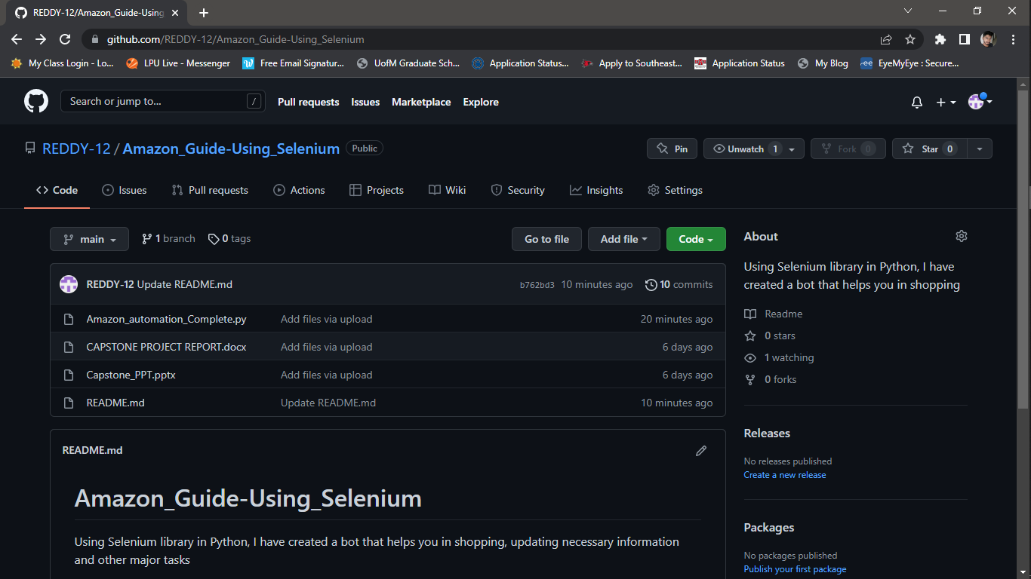

1. **Challenges Faced and Areas of concern**

**4.1 Challenge faced in Sign Up page**

When we started automating the sign up page, the first challenge we faced is that there were 2 different types of login forms which open randomly every time we open the page. The solution to solve this problem is if-else loop. We created loop to enter data based on the sub - heading of the form.

**4.2 Concern in Sign Up page**

Every website uses captcha to stop the robot from operating the website. In our case after submitting the sign up form there is a puzzle popping up to restrict the bot. As the main purpose of the puzzle is to restrict the bot, we were unable to automate the captcha. So the user needs to enter the otpdirectly in the automated page created. After creating an account user can come back and run the bot again and go for sign in.

**4.3 Empty fields in Cost and Rating**

When we see the details of search items in amazon not all items have cost andrating displayed. In this case when we fetch the cost or rating we get an errorwhen the field is empty.

So to overcome this issue we used “try – except” block. This block helps us todeal with the exception and run the program without any interruption.

**4.4 Infinite loop after Sign Out**

After signing in successfully and after performing all the necessary actions, if you click on sign out you will be logged out of the account but the program prints one line infinitely and we were unable to rectify the issue but if you do the same thing after entering through forget password the code exits successfully.

1. **Conclusion**

* When a person is new to any website he/she doesn’t know where to start with. We usually need assistance from someone.
* Using automation we can make the interaction with the website much easier to the users without any external assistance. It is possible to automate entire website with ease using selenium.
* The sole purpose of “Automation” is to reduce the human effort.
* Though we can automate almost everything, there are some tabs that can never be automated, the reason being the purpose of those tags is to keep bots from using the site.
* Overall using automation can make us more closer to the technical world.